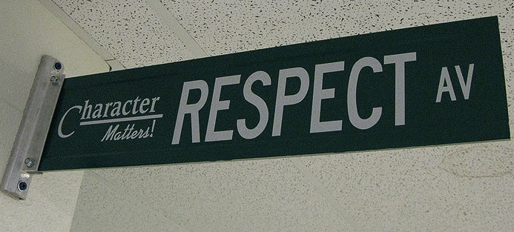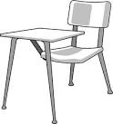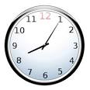

#### Ask permission to leave the classroom.

## Homework

Homework is not busywork. It is necessary for you to complete in order to participate in class the next day or to develop important skills. You will be given a calendar of homework for larger assignments to help you keep track of these assignments and break them into smaller tasks. If you choose not to complete the assigned work, you are missing out on the opportunity to learn and grow.

Homework assignments may include, but are not limited to:

* Independent reading
* Practice sets to reinforce newly introduced skills
* Vocabulary activities
* Articles of the Week
* Responding to writing prompts
* Project completion/design

Welcome to ELA. Our goal for the year is to learn to read and think as writers, to look at texts through a writer’s eye. We will be reading and writing poetry, narratives, informational, and argumentative texts. You will have the opportunity to read engaging, thought-provoking texts and novels you won’t want to put down. By examining these exemplary texts, you will build your skills as a writer and be able to communicate your ideas effectively. We will also spend time building your vocabulary and technology skills. Discussion, both speaking and listening, as well as working in collaboration with others will play a large role in class as well. I look forward to spending the year learning with you!

# Course Description

#### Be kind & be respectful.

### Class Expectations

#### Follow directions the first time they are given.

#### Raise your hand and wait to be called on before speaking.

All school rules also apply.

#### Be on time & be prepared.

ELA 6th Grade

School Grading Scale

Excellent ...............................................93% - 100%

Good .....................................................85% - 92% Average.................................................75% - 84% Passing..................................................65% - 74% Failure...................................................Less than 65%

## Positive & Negative Consequences

Meeting classroom expectations and behaving appropriately in class helps to create a learning environment where you and your classmates feel welcome, safe, and respected.

If you choose to meet the classroom expectations, you will receive a **positive consequence**, such aspraise from teacher, classmates, administration, “Shout Outs,” a positive note or phone call home, special privileges/activities, and awards.

If you choose not to meet the classroom expectations, you will receive a **negative consequence,** such as a verbal warning, a change of seat, a student/teacher conference, a phone call home, a detention, a parent/guardian meeting, and for severe infractions of classroom/school rules, a principal referral.

**YOU WILL NEED:**

* A composition book & folder to keep in the classroom
* Writing utensils (pens or pencils)
* A Gmail account (the school should have this ready for you)
* Planner
* A positive attitude, a sense of humor, & an open mind

**Entering Class:** Gather any necessary materials, quickly find your seat, and begin working on the warm-up posted on the board. This is a timed five-minute activity.

**Bathroom Usage:** Schoolwide policy states students may not leave class without signing out. A sign out area is posted in the classroom. You must have a hall pass.

**Food & Electronic Devices:** Food and drink are not permitted outside of the cafeteria for sanitary reasons. Electronics should not be seen or heard in the classroom.

**Exiting Class:** In the last five minutes of class, you will wrap up what you are working on, return materials to the appropriate locations, and complete an exit ticket which will be handed in on your way out the door. The teacher, not the bell, dismisses you upon completion of these tasks.

**Absences:** If you are absent, it is your responsibility to make up missed assignments. See the “While You Were Out Folder” for handouts.

**Revise & Redo:** Many assignments, especially our writing pieces, will require multiple attempts. An assignment will not be considered complete until it meets the checklist criteria for that assignment.

## Classroom Policies, Procedures, & Grading